**Lab2 Advanced Sql**

**Q1:** **Add gender column for the student table. It holds two value (male or female)**



**Q2:** **Add birth date column for the student table.**

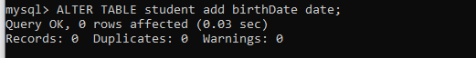

**Q3:** **Delete the name column and replace it with two colums first name and last name.**

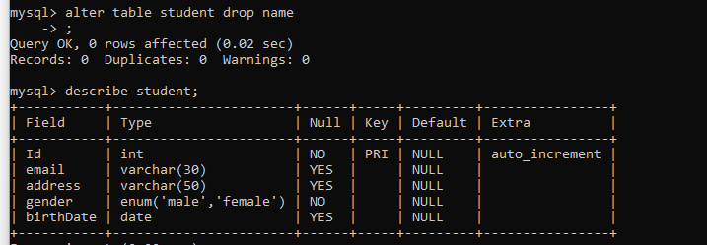

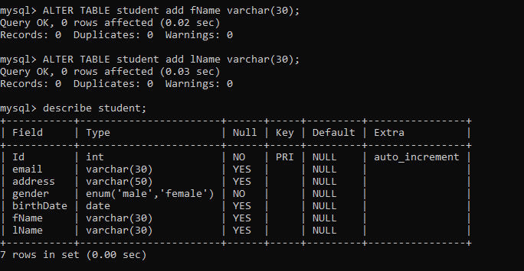

**Q5:** **Add foreign key constrains in Your Tables with options on delete cascaded**

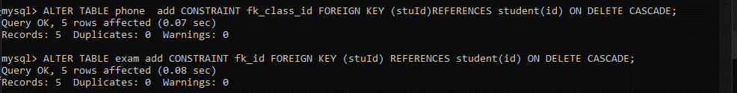



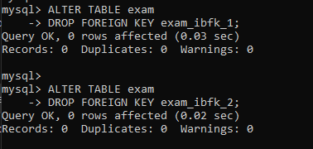

**Q6:** **Update your information by changing data**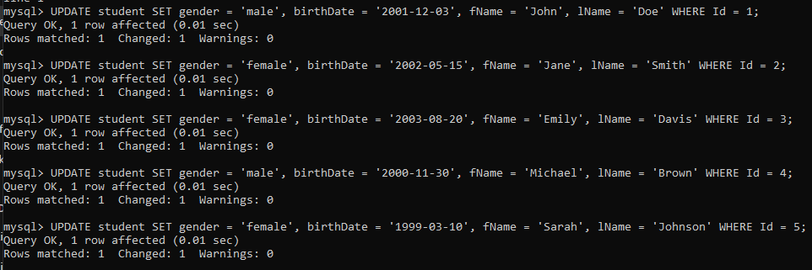

**Q7:** **Display all students’ information.**

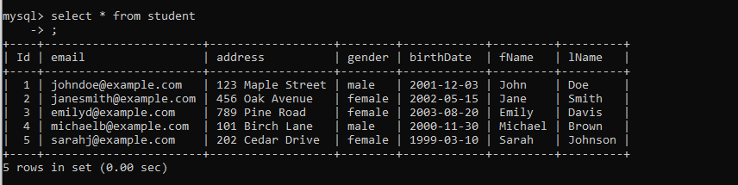

**Q8:** **Display male students only.**

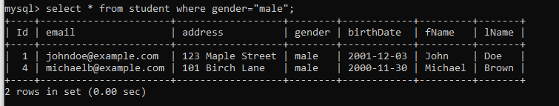

**Q9:** **Display the number of female students.**

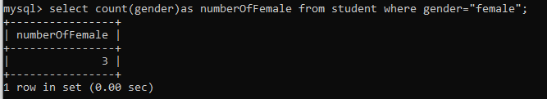

**Q10:** **Display the students who are born before 1992-10-01.**



**Q11:** **Display male students who are born before 1991-10-01.**



**Q12:** **Display subjects and their max score sorted by max score.**

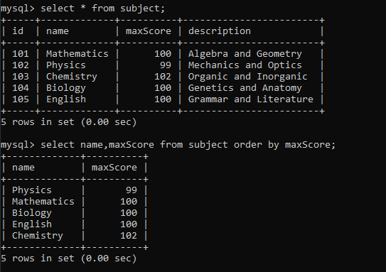

**Q13:** **Display the subject with highest max score**

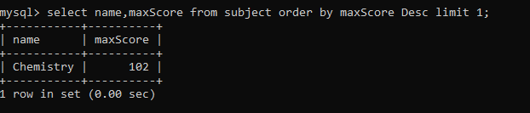

**Q14:** **Display students’ names that begin with A.**



**Q15:** **Display the number of students’ their name is “Mohammed”**

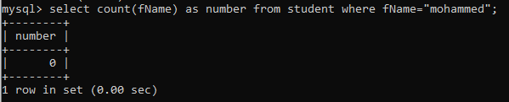

**Q16:** **Display the number of males and females.**

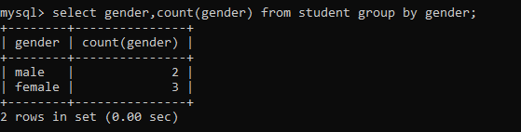

**Q17:** **Display the repeated first names and their counts if higher than 2.**

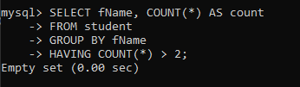

**Q18:** **Display students’ names, their score and subject name.**

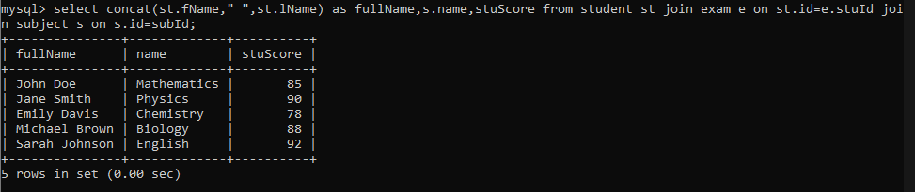

**Q19:** **Delete students their score is lower than 50 in a particular subject exam.**

